**Fiori App Extension**

**Step1:** Right click on Workspace ->New->Extension Project

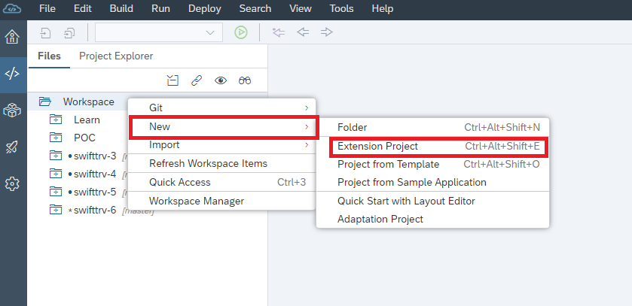

**Step2:** Expand dropdown and select SAP ABAP Repository and press Next Button.

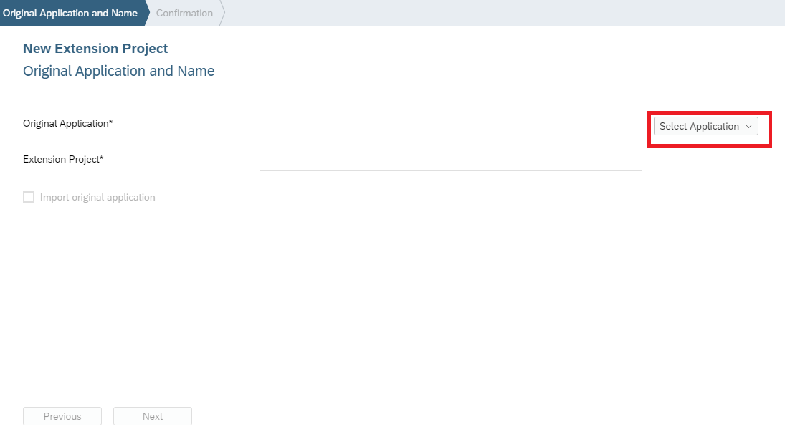

**Step3:** select your abap repository system and select application

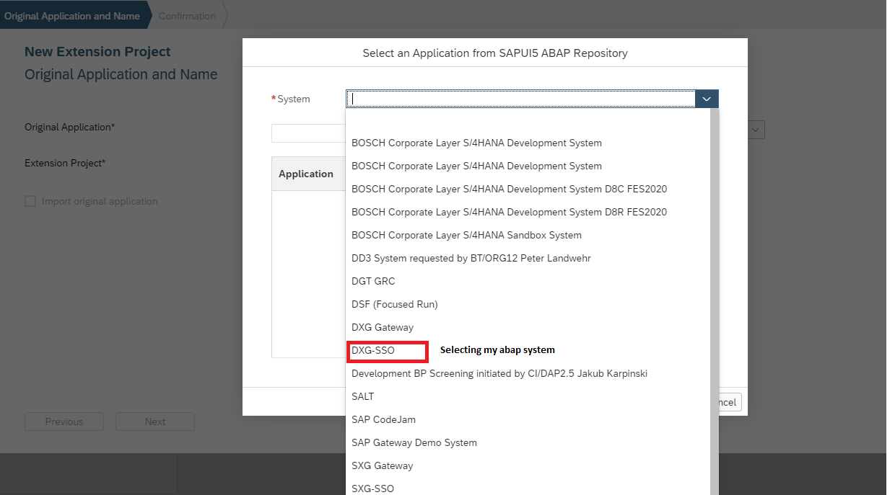

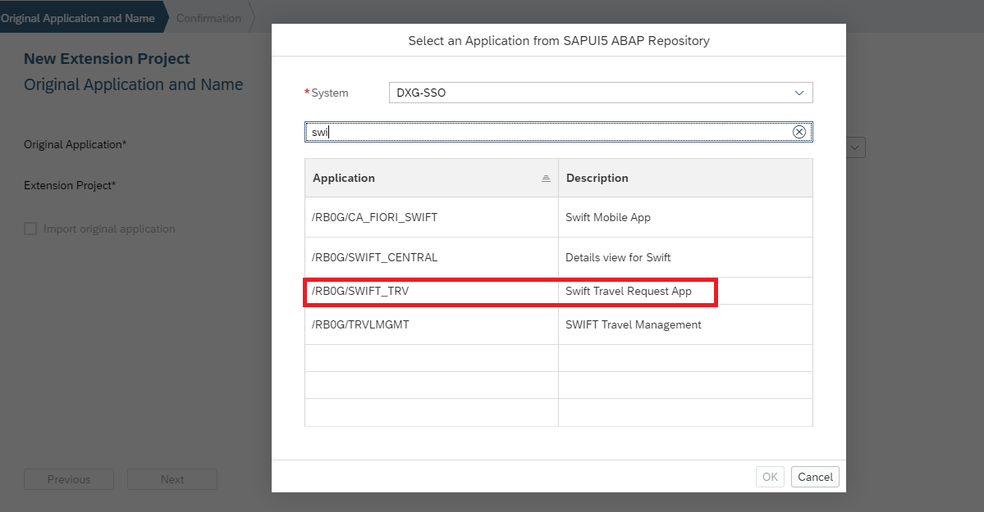

**Step4:** Press Ok Button then we can see our application

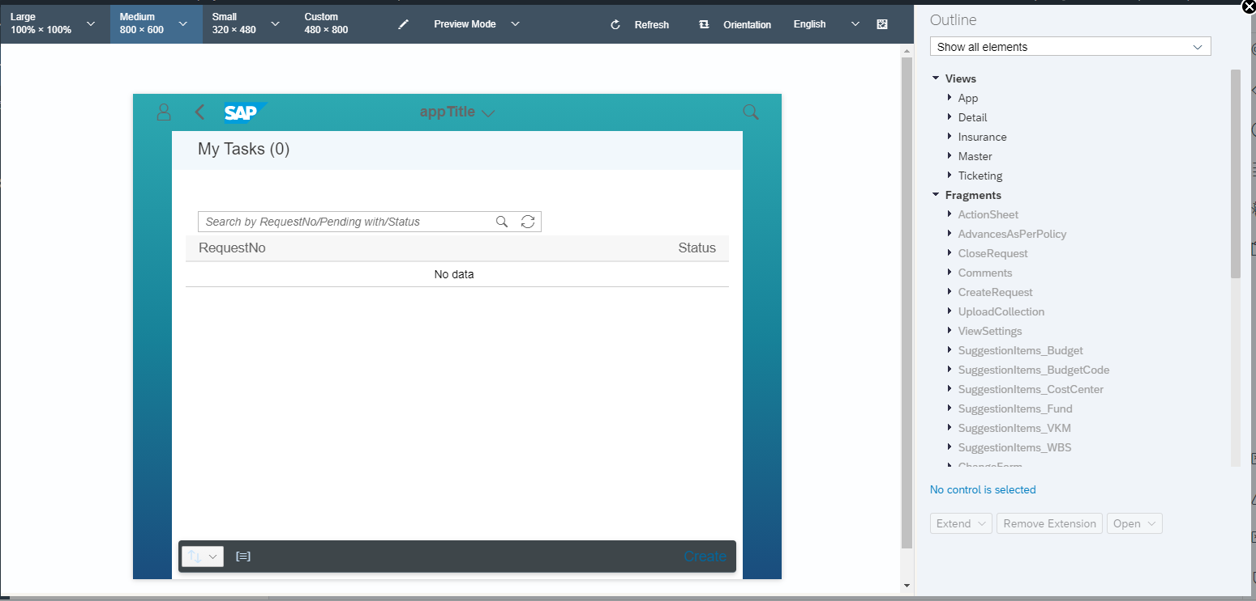

**Step5:** and right hand side we can see all UI elements, project folder.

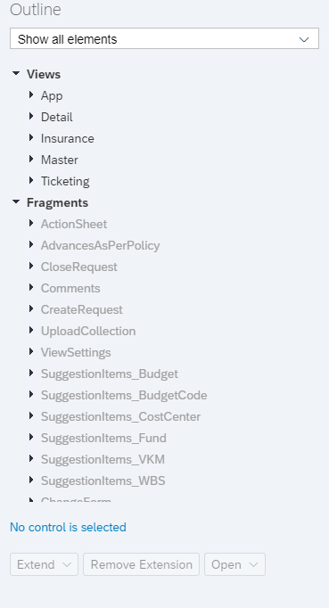

**Step 6:** Select view and Press expand button to see options.

**Expand Dropdown contains:**

1. Replace with empty view

2. Replace with copy of original view

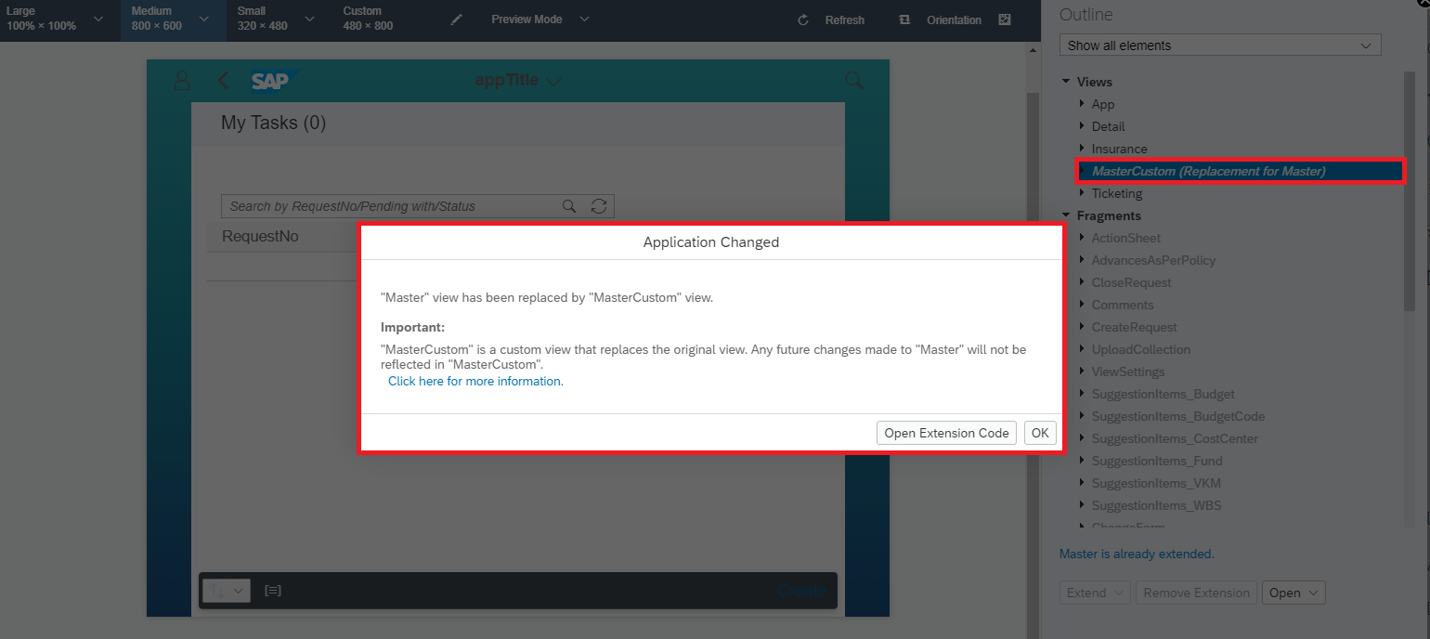

**Step7:** Press Open extension Code.

**Step8:** Project structure will be changed. Now you can able to modify MasterCustom View.

